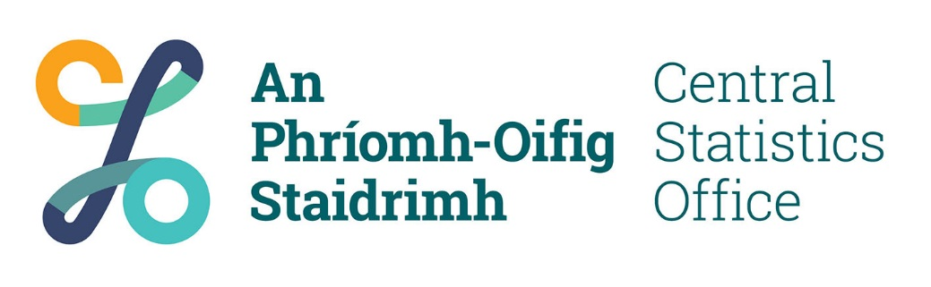

Documents for Management of Remote Working During Covid 19 Crisis

**To All Staff & Line Managers**

I hope that you and your families are keeping well during this very difficult time.

As the Director General stated in his message dated 31 March 2020, “we are now settling into the new ‘normal’”. I agree with the Director General that very little of this seems normal.

Understanding that this period is challenging for all of us your continuing professionalism and commitment is recognised and much appreciated.

To facilitate the changes in our working arrangements the Office is requiring that all staff and line managers working remotely to complete the forms below and return to your line manager.

This form is designed to ensure that line mangers and staff can maintain communications and working relationships during the current Covid 19 crisis.

I am aware that many of you are working from home while balancing caring commitments. In light of this, those with remote access, over 800 as at 31 March, can access CSO systems outside the core working day of 8 am to 7 pm. Unless requested by your manager, there is no requirement to be working from 10 am to 12:30 pm or 2:30 to 4 pm. Please note Appendix 2 below for information about the Organisation of Working Time Act, 1997[1].

I would ask that you complete Parts 1, 2 and 3 of this document and return to your line manager as soon as possible but no later than Tuesday 7April. Line managers should acknowledge the completed form and forward to [personnel@cso.ie](mailto:personnel@cso.ie) with the name of your **section** in the subject line and **RWA, e.g. HR Recruitment & Vacancy Management – RWA**

If you have any queries in relation to this document please contact Mark Lyons, [mark.lyons@cso.ie](mailto:mark.lyons@cso.ie) or Catherine Desmond, [catherine.desmond@cso.ie](mailto:catherine.desmond@cso.ie) .

I wish you and your families well during this difficult time.

Take care and be safe.

Marie Creedon

HR Manager

31 March 2020

**COVID-19 Remote Working**

**Record of Arrangements**

Parts 1, 2 and 3 to be completed by Staff member.

Upon completion forward to Line Manager at CSO email address for completion of Part 4. The Line Manager will forward completed forms to HR. HR will be collecting and retaining this information as per privacy notice below.

Where Line Manager contact details have not been shared at time of completion, mark as “to be shared.” Line Manager must address this immediately.

**Part 1 Personal Details**

|  |  |
| --- | --- |
| Employee Name |  |
| Grade |  |
| Division, Section and Office Location |  |
| Work Mobile |  |
| Alternative Phone |  |
| Office email (this will be primary email where remote access available) |  |
| Alternative home email (*to which the staff member has access and can be sent Office updates*) |  |

**Part 2 Line Manager Details**

|  |  |
| --- | --- |
| Name of line manager |  |
| Grade of line manager |  |
| Division, Section and Office Location of line manager |  |
| Contact Phone of line manager for duration of remote working |  |
| Contact email of line manager |  |

**Part 3 Remote Working Arrangements**

|  |  |
| --- | --- |
| Date remote commenced |  |
| Address at which remote working will be carried out |  |
| Equipment to be used (e.g. laptop, desktop, tablet etc and specify if corporate or personal). |  |
| If not in a position to work from home please Indicate what is reason, e.g. broadband or IT equipment |  |
| Details of agreed system of contact with manager/the Office (eg daily phone call/daily email update etc) |  |
| Details of work to be carried out from home (core work; special project (specify); alternate assigned duties (specify)  If no work assigned, please state “none.” |  |

Please read the following and tick each box.

|  |  |  |  |
| --- | --- | --- | --- |
| I acknowledge that I have read and understand the contents of the linked documents from the Department of Public Expenditure & Reform[2] | | |  |
| I agree to adhering to the Organisation of Working Time Act 1997(OWTA).[3] | | |  |
| I understand the importance of taking appropriate breaks from work[4] | | |  |
| I acknowledge that I have read and understand the contents of the linked Health & Safety Authority documents[5] | | |  |
| My work will be stored securely and not accessible to others in my home/outside my office | | |  |
| I have read and understand the CSO ICT Acceptable Usage Policy | | |  |
| I have read and understand the requirements of the CSO Data Management Policy and I confirm that I will comply with its provisions as they apply to remote access to CSO systems | | |  |
| I understand that normal provisions apply to sick leave, annual leave, etc and undertake to apply/inform my line manager as required. | | |  |
| I have read and understand the contents of this document | | |  |
| **Name of Staff Member:** |  | **Date:** |  |

Please email this completed form to your line manager for approval.

**Part 4 Line Manager Acknowledgement**

I have discussed the form as completed with the above named. Where not previously provided I have shared my contact details.

|  |  |  |  |
| --- | --- | --- | --- |
| Name of Line Manager: |  | Date: |  |

Please email this completed form to [personnel@cso.ie](mailto:personnel@cso.ie) with the name of your **section** in the subject line and **RWA, e.g. HR Recruitment & Vacancy Management – RWA.**

Line Managers should, where possible, collect all returns into a single email to facilitate collation.

The data collected on this form will be used for the Office to record remote working and to provide anonymised data on those working from home. The contacts provided may be used to provide information from the Office while the person is remote working and manage health, safety and wellbeing matters.

**Appendix 1**

**Data Protection Transparency Notice for the Facilitation of Remote Access by Staff**

**Purpose and Legal Basis**

This transparency statement relates to the privacy practices of the Central Statistics Office (CSO), in connection with personal data processed by the Office during the facilitation of remote access by staff, who use their own personal computers, laptops and mobile phones or CSO equipment remotely or work on CSO data offline, as a business continuity response to the Covid 19 alert in Ireland in March 2020.

It may be necessary for the CSO to process your personal data so that the Office can implement a business continuity response because of the Covid 19 alert in Ireland. The data will be processed in accordance with Article 6(1)(f) of the General Data Protection Regulation 2018.

The data will be collected directly from staff and will be used to facilitate remote access in the event of an Office shut down or a self- isolating issue caused by the Covid 19 virus. The data will remain confidential, will be used exclusively for this purpose and will be retained for no longer than six months after the end of the current Covid-19 alert commencing March 2020.

The type of personal data that will be processed for the facilitation of remote access by staff is a personal mobile phone number and/or email address.

**Data Protection Rights**

The CSO respects the principles of the General Data Protection Regulation and the rights of the individual as defined therein. Under the General Data Protection Regulation, you have the following rights:

* The right to lodge a complaint with the Data Protection Commission. Contact details: Office of the Data Protection Commission, 21 Fitzwilliam Square South, Dublin 2, D02 RD28, Ireland.
* The right to request access, rectification, erasure, restriction or to object to the processing of your personal data.

**Central Statistics Office Data Protection Officer Contact Details:** [**DPO@cso.ie**](mailto:DPO@cso.ie)

**For further information on your data protection rights and how your data is used please contact:**

Orla O’ Gorman

International, Policy and Planning Division

Phone: 021 454 5659

Email: [Orla.OGorman@cso.ie](mailto:Orla.OGorman@cso.ie)

**Appendix 2**

Please see extract from Office Notice 9/2020 below

**“Working from Home**

Staff working from home are not required to clock in/out. but are required to keep a record of working time as per the Organisation of Working Time Act, start times, end times and breaks. This record should be submitted to your line manager on an agreed regular basis. The Act states that breaks should be as follows;

Up to 4 Hours and 30 minutes worked – a minimum break of 15 minutes

6 hours worked or more – a minimum break of 30 mins

Staff remote working should note the FAQs issued by the Health & Safety Authority at <https://www.hsa.ie/eng/news_events_media/news/news_and_articles/faq%E2%80%99s_for_employers_and_employees_in_relation_to_home-working_on_a_temporary_basis_covid-19_.html>

Staff should also refer Health and Safety Information for Remote Workers at Appendix A.”

1. <https://www.citizensinformation.ie/en/employment/employment_rights_and_conditions/hours_of_work/rest_periods_and_breaks.html>
2. See DPER FAQs at <https://www.gov.ie/en/news/d2536d-covid-19-faqs-for-hr-in-the-civil-and-public-service/>
3. *Please note that there are no restrictions on when work is carried out once it does not breach the OWTA rules*. The Office understands that many of you have caring responsibilities at home and may have to plan your work hours around these for this reason citrix is available outside of the normal 8 to 7 working day.
4. See Office Notice 9/2020 at <https://www.cso.ie/en/media/csoie/staffnews/Office_Notice__9_2020_Attendance_Arrangements__COVID-19_Delay_Phase.pdf>
5. <https://www.hsa.ie/eng/news_events_media/news/news_and_articles/faq%E2%80%99s_for_employers_and_employees_in_relation_to_home-working_on_a_temporary_basis_covid-19_.html>