

**HOW TO ACCESS ELEARNING**

1. Email your Learning and Development Team at [training@cso.ie](mailto:training@cso.ie) to request an account
2. The team will issue you with your credentials
3. To access Percipio, please click into Lotus Notes and click on the Learning & Development tab, and click on eLearning

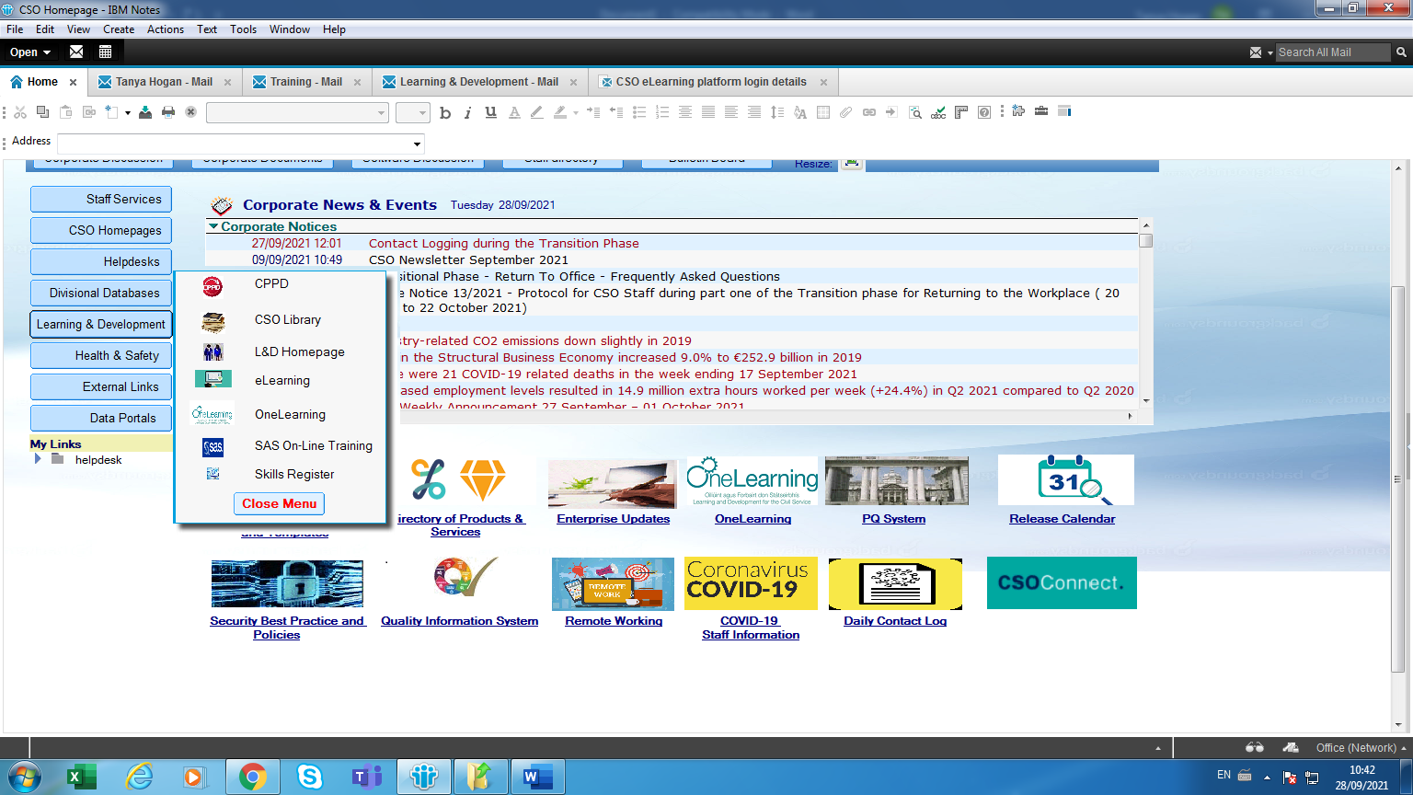



Any questions please email training@cso.ie