Non Financial Corporate Debt - A Macroeconomic Perspective

The Non-Financial Corporations Institutional Sector contains the largest grouping of companies in the economy. This classification includes all company sizes from extremely large Multinational Corporations located in Ireland down to small retail operations. The activities covered fall under the broad headings of Industry, Construction, Distribution and Services, excluding Financial Services. This Institutional Sector cover 199,000 enterprises and the majority of these entities are either termed micro having less than ten employees or small i.e. less than fifty employees.

An analysis of debt by Institutional Sector across a number of companies as a percentage of Gross Domestic Product (GDP) is shown below
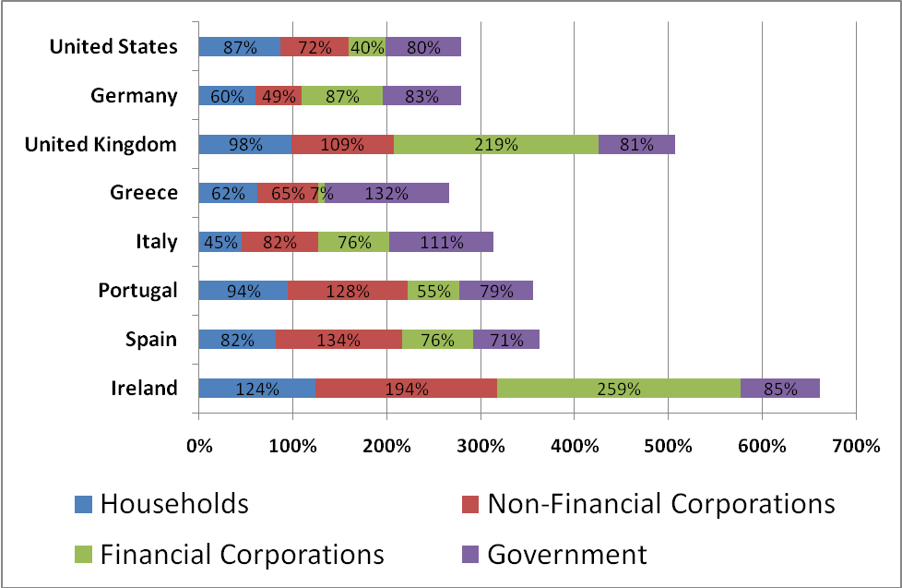
The chart demonstrates the levels of debt for each institutional sector relative to annual GDP at current prices. These same measures form the building blocks for the Scoreboard for the Surveillance of Macro Economic Imbalances - the so-called six pack. One measure is particularly relevant to this presentation ; Private sector debt has a threshold of 160% of GDP. This is represents a combination of Households, Financial and Non-Financial Corporations. Clearly Ireland has breached this threshold, however while the level of household debt is well understood following the boom years, the corporate debt needs more examination. Today we are concerned with the Non-Financial element of this debt, that alone stands at almost twice the level of GDP.
To fully understand this situation it is necessary to look at the components of this debt. Firstly a large element of Ireland’s debt is International in nature and is held by companies operating in the International Financial Services Centre. While these companies are not part of the non-financial sector, they are nevertheless related to the Non-Financial Sector in particular through the activities of Treasury companies related to Multinational Corporations. These Treasury companies optimise the cash management of an MNE and are engaged in intra group borrowing and lending. Accordingly an element of the debt of the NFCs is owed to these Treasury companies. MNEs are also engaged in borrowing from other affiliates in Ireland and also from affiliated and banks located abroad.

