BOP44 Guidance Notes

Instructions for the Completion of the BOP44 Form

1 July 2024

Balance of Payments & Financial Sector

Central Statistics Office

Email: [bop@cso.ie](mailto:bop@cso.ie)

Tel: +353 1 498 4050

Contents

Section 1: Overview 3

1.1 Introduction 3

1.2 Legislative Basis 3

1.3 Who Should Report 3

1.4 Reporting Currency 3

1.5 Period Covered 4

1.6 What Should be Reported 4

Section 2: Completing the Form 5

2.1 Structure of the Form 5

2.2 Register 5

2.2.1 Information 5

2.2.2 Register 6

2.3 Profit & Loss 7

2.3.1 Income 8

2.3.2 Expenditure 9

2.3.4 Profit and Loss 10

2.4 Balance Sheet Items 11

2.4.1 Equity Investment 11

2.4.2 Assets and Liabilities 12

2.4.3 Shareholders’ Funds 16

2.4.4 Balance Sheet Summary 17

Section 3: Appendix 18

3.1 Definitions 18

3.2 Treatment of Instruments 22

3.3 ISO Country Codes 24

# Section 1: Overview

## 1.1 Introduction

The BOP 44 form is intended to cover the activities of Irish-resident ***stand-alone treasury companies***. All positions and changes in assets and liabilities are to be reported for the period covered by the form.

The below notes are intended as guidelines on completing the form and care should be taken to read them before completing it. However, not all situations can be covered in these notes. Please email us at [bop@cso.ie](mailto:bop45@cso.ie) if further guidance is required.

## 1.2 Legislative Basis

**National:** S.I. No. 91/2020 - Statistics (Balance of Payments Survey) Order 2020

**European:** Regulation (EU) 2016/1013 of the European Parliament

The enforcement powers of the Office are contained in Part VI of the Statistics Act, 1993. Failure or refusal to provide any requested information in response to a direction from the Director General is punishable by a maximum fine of €2,500 on summary conviction or €44,440 on conviction on indictment (Section 44). Continued failure to provide requested information after conviction is punishable by a maximum daily fine of €500 on summary conviction and €2,222 on conviction on indictment.

## 1.3 Who Should Report

Only those companies which are **tax-resident** in Ireland are included in the BOP44 survey.

Any such company that meets the qualifying criteria set out in Article 5.1 of S.I. No. 91/2020 is required to provide a BOP 44 form to the CSO on a quarterly basis. A completed return must be provided within **21 days of receipt of the form** at quarter-end.

Irish-resident **Section 110 companies (SPVs)** reporting to the Central Bank under Section 18 of the Central Bank Act 1971 should not be covered by a return.

## 1.4 Reporting Currency

In general respondents are expected to report in euro (rounded to the nearest million), provided this does not cause material inaccuracies. If reporting in euro is inconvenient, please report in your main foreign currency clearly denoting the currency used.

When reporting in euro, balances denominated in foreign currencies are to be converted at mid-market exchange rates on the balance sheet date, and transactions at actual rates on the date of transaction (if available, otherwise at the average market rate in the period). If a budget exchange rate is used please indicate this rate on the form.

## 1.5 Period Covered

Ideally reports should relate to the calendar period specified. If your accounting period is not as specified and cannot be readily adjusted, you should report for your accounting period ending closest to the specified period and indicate this clearly on your return. It would be useful if you could give details in a separate note of any major transactions or events which would cause differences between the reported data and calendar period data.

## 1.6 What Should be Reported

The questionnaire relates to transactions between the Irish part of your group and all counterparties, both resident and non-resident. Counterparties may include your overseas affiliates (parent, Head Office, subsidiary, branch, associated company, etc.)

Profit & Loss and Balance Sheet data is to be reported giving a geographical breakdown of the flows arising from assets and liabilities of the Company.

All positions and changes in assets and liabilities are to be reported. This includes the following:

* Principal and income flows, on an accruals basis, relating to the lending, leasing, sales finance activities and other income flows.
* Ownership and investment into the Company by shareholders.
* Operating costs of the Company including fees; those relating to investment advice, administration, custodian services, commissions, brokerage, etc.
* Profits earned and dividends payable.
* Investment assets and liabilities of the Company including Equities, Bonds and Notes, Bank Deposits, etc.
* Transactions and balance sheet positions, together with related investment income earned/payable, on an accruals basis.
* Valuation changes due to market price and exchange rate movements.

Assets and liabilities are to be reported over the following main categories:

* shareholders holding 10% or more of the Company's equity, together with their subsidiaries and associates, i.e. related companies (see definition of direct investment in Section VI of these notes).
* branches, subsidiaries, associates, and other investments of the Company of 10% or more in another company's equity.
* unconnected third parties.

# Section 2: Completing the Form

## 2.1 Structure of the Form

The principles of the BOP44 form are similar to those of the financial accounts for a company. Entries are recorded following a consistent set of accounting principles to ensure a complete integration of flows and positions as well as symmetry of recording between counterparties.

The form is divided into three distinct sections:

1. Register
2. Profit & Loss
3. Balance Sheet Items

## 2.2 Register

### 2.2.1 Information

After completing the form, please fill in your details in the Declaration on the Front Page. The signature on the Declaration may be typed in – there is no need to submit a separate handwritten signature.

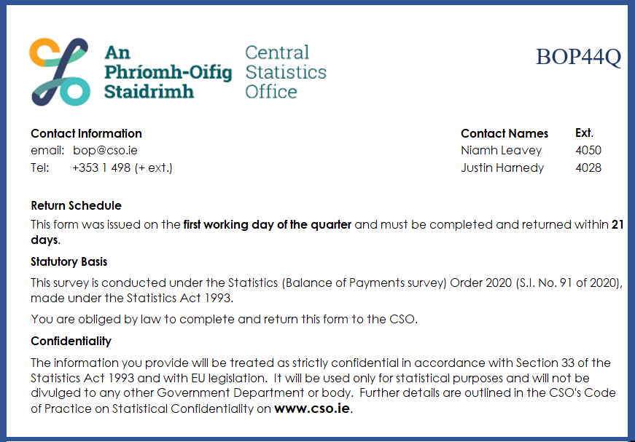

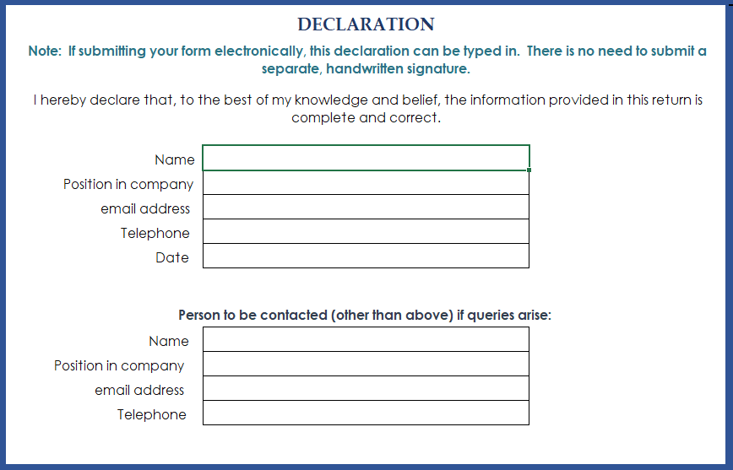

### 2.2.2 Register

The Register worksheet collects data on the units and currency used to complete the remainder of the form, as well as details on the company.

Guidance on the **Reporting Currency** and **Units** is given in Section 1.4. Respondents are expected to report in euro rounded to the nearest million, provided this does not cause material inaccuracies. If reporting in euro is inconvenient, please report in your main foreign currency clearly denoting the currency used. If the reporting currency is not available in the dropdown list in cell C8, then please select Other and put the currency code in cell D8.

Guidance on the **Period Covered** is given in Section 1.5. Ideally reports should relate to the calendar period specified. If your accounting period is not as specified and cannot be readily adjusted, you should report for your accounting period ending closest to the calendar period and indicate this clearly on your return. The preferred format for recording a calendar quarter in this field is *YYYYQQ*.

The accounting standard used in the preparation of financial statements should be recorded in the **Basis of Preparation** field in cell C10.

For companies incorporated and tax-resident in Ireland a single form is required covering a group or a company resident in Ireland. All **Irish subsidiaries** of a group should be included in this form and listed on the *Register* worksheet. The relationship to your company of other Irish tax-resident entities which are included in the return should be selected from a drop-down list in column C. If, for some reason, subsidiaries are excluded, please indicate this in column E and supply details of these subsidiaries so that arrangements can be made for the completion and return of separate forms.

The highest-level Irish company (the Irish parent) or the Irish Head Office (in the case of branches) is responsible for making a combined return. Subsidiaries or branches receiving the survey form should forward it with these instructions to the parent or Head Office to have the form completed. The CSO should be informed of these arrangements, where applicable.

For branches of foreign companies, the Irish branch is required to complete this return. If the company has two or more branches in Ireland (e.g. in different locations and/or engaged in different activities), a single return covering all the branches should be submitted. All branches covered should be listed in the Register worksheet of the form.

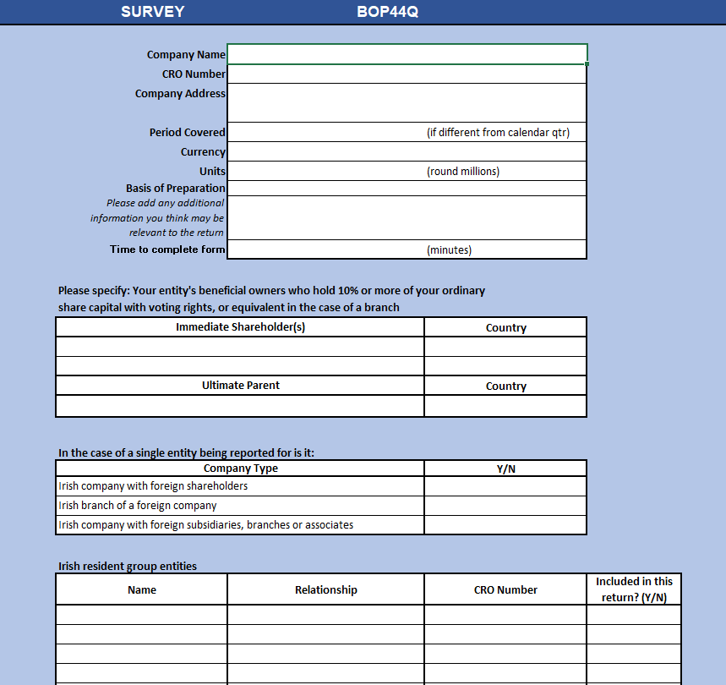

The relationship to your company of other Irish tax-resident entities which are included in the return is selected from a drop-down list.

The relationship to your company of other Irish tax-resident entities which are included in the return is selected from a drop-down list.

## 2.3 Profit & Loss

Profit & Loss data should reflect the period covered (in particular, year-to-date values should not be recorded in respect of quarterly periods, save the first quarter where these values coincide).

Profit & Loss data is to be reported giving a geographical analysis of the flows of assets and liabilities of the Company. Income and Expenditure are recorded in separate worksheets. In all cases interest is to be recorded on an accruals basis. Both income and expenditure are to be recorded using non-negative values (with exceptions allowed in cases where negative income/expenditure is intended). Capital and exchange gains/losses (realised and unrealised) are to be excluded from income and reported separately in cell D6 of the Profit and Loss worksheet with no geographical breakdown required.

In the *Income* and *Expenditure* worksheets, a 2-letter ISO country code must be entered in column A. This may be typed or selected from the dropdown list. A list of ISO country codes and corresponding countries is available in columns A and B of the *Codes* worksheet. Column B will autofill with country name for that code. Data for the reporting period should then be entered for each field in row three of the worksheet. Cells in row one will auto-calculate the total for each field while column K in the *Income* worksheet and column O in the *Expenditure* worksheet will auto-calculate totals for each country.

All cells with embedded formulae are locked so no alterations can be made to these cells.

### 2.3.1 Income



**Non-Interest Income Items:**

* Fees & commissions receivable: Fee income relating to financial services only.
* Operating lease income: Income on operating leases.
* Other Income n.e.c. (non-Interest income): Other income from ordinary operating activities that cannot be classified elsewhere. This column should not contain income of an exceptional nature (e.g. profit on disposal of assets), as such items should instead be reported as capital gains in the Profit and Loss worksheet.

**Interest Income Items:**

* Third parties (loans & deposits): Interest (on an accruals basis), earned on loans to third parties and deposits with third parties.
* Group companies (loans & deposits): Interest receivable from group companies on loans or deposits, on an accruals basis, including interest income from sales financing arrangements.
* Finance leases: Interest element of lease payments received.
* Debt Securities: Interest income on an accruals basis from Bonds & Notes or Money Market Instruments.
* Derivatives - Net interest income receivable (include with positive sign), or payable (include with negative sign) on interest rate swaps, cross-currency interest rate swaps and forward rate agreements (FRA's), should be recorded here. All other income on derivatives, which is not related to interest payments/receipts, should be recorded under Capital & Exchange gains/losses.

### 2.3.2 Expenditure

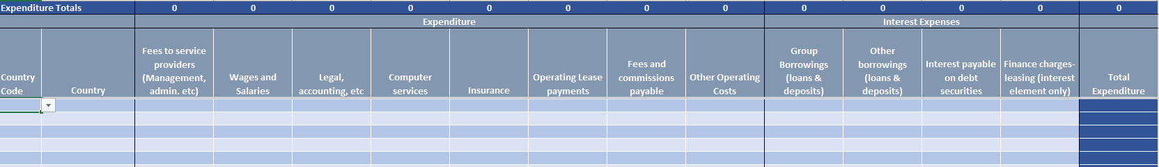

**Expenditure:**

* Fees to service providers (Management, admin., etc): All fees payable to service providers for management, administration etc.
* Operating Lease payments: Expenditure on operating leases.
* Fees and commissions payable: All financial fees and commissions payable.
* Other Operating Costs: Any costs (excluding depreciation) not already detailed in the previous items that relate to ordinary operating activities. Where significant, some accompanying details would be helpful. This column should not contain costs of an exceptional nature (e.g. impairment, loss on disposal of assets), as such items should instead be reported as capital losses in the Profit and Loss worksheet.
* A country breakdown of general expenses such as Wages & Salaries, Legal, accounting, etc, Computer services, and Insurance should also be provided.

**Interest Expenses:**

* Group Borrowings (loans & deposits): All interest payable to related companies on loans and deposits, on an accruals basis.
* Other borrowings (loans & deposits): All interest payable to third parties on loans and deposits, on an accruals basis.
* Interest payable on bonds & MMI's: Interest payable on Bonds or MMI's issued.
* Finance charges-leasing: The interest element of financial lease payments.

### 2.3.4 Profit and Loss

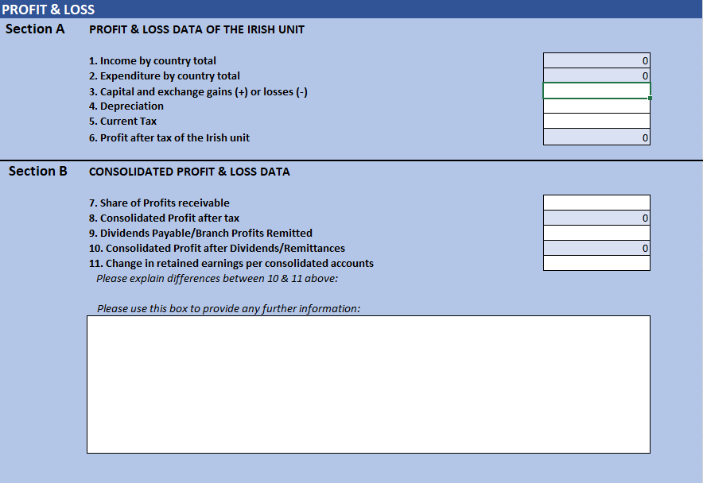

**Section A**

Items 1 and 2 are auto-calculated based on data provided in the *Income* and *Expenditure* worksheets. All capital and exchange gains/losses, both realised and unrealised, should be entered in the *Profit and Loss worksheet*. These gains/losses are to be excluded from income and entered separately under item 3 with no geographical breakdown required. Depreciation (Item 4), and any current tax payable directly by the company for the reference period (Item 5) should be recorded in this section. The value recorded in Item 4 should only reflect ordinary wear-and-tear depreciation of relevant assets. In particular, any recognition of asset impairment should be recorded under capital and exchange gains/losses. However, both depreciation and impairment should be recorded as a valuation change for the relevant balance-sheet item. Regarding Item 5, we request that deferred tax not be included in the value recorded here, although deferred tax may be recorded in the balance sheet when recording movements in retained earnings under Shareholders’ Funds.

**Section B**

Share of profits receivable: This should include the Company's share of any profits/losses earned in the period by branches, subsidiaries, and associates (as recorded in 3.1.1 Column 10) along with any dividends receivable from portfolio investments (as recorded in 3.1.2 Column 11)

Items 8 and 10 are auto-calculated based on information provided.

The comment box can be used to provide details of any siginificant events from the reference period as well as to explain differences between Consolidated Profit after Dividends/Remittances (Item 10) and Change in retained earnings per consolidated accounts (Item 11).

## 2.4 Balance Sheet Items

In this section, we look for the opening and closing balances for each asset/liability class for the reference period. These should correspond to the statement of financial position in the financial accounts of a company with an additional geographical breakdown. All related cash flows in the period should be reported as transaction increases and decreases.

Every item on the balance sheet should be recorded in the worksheets *Equity Investment*, *Assets*, *Liabilities* and *Shareholders’ Funds*.

**In cases where a geographical breakdown is not available, careful estimates are acceptable**.

### 2.4.1 Equity Investment

Equity securities are ordinary shares which give the holder the right to a proportional share of the net assets of the company. Other forms of security which do not have this characteristic even if described as “shares”, e.g. non-participating preference shares, should be included under Bonds and notes (see Section 3.1 for definition and instruments considered to be equity investment).

If an Irish company has foreign subsidiaries or branches (or Irish subsidiaries/branches which are not included in the form) we need to show such investments at an approximation to the current valuation. The amount invested is not sufficient. We need the amount invested plus profits retained, less any impairment provision.

Increases/decreases in the opening and closing values due to share price changes should be shown under “Valuation changes”.

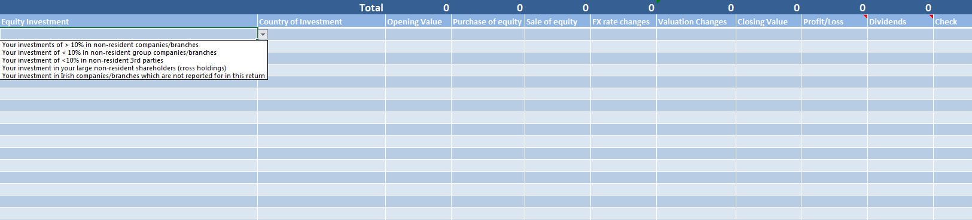

**Equity Investment** type is selected from a drop-down menu in the first column. The **Country of Investment** is also selected from a drop-down menu.

Opening value should equal the closing value of the previous quarter.

Profit or loss of investments for the quarter

Dividends Payable/Branch Profits remitted to Ireland during the quarter

#### 2.4.1.1 Types of Equity Investment

**Non-resident companies/branches (>= 10%):** You should report your equity investments including branch capital into companies and branches. You are required to show market value of the investments categorised as indicated in this section of the form. Please see the definitions of the different types of investment in Section VI of these notes. You must report this information with a geographical breakdown. Your share of the profits earned in the period by your subsidiaries, associates and branches should be entered in Column J - Profits/Losses. The corresponding dividends received should be entered in Column K - Dividends.

**Non-resident group companies/branches (<10%):** As this investment is treated as portfolio investment, no profit should be entered and Column J - Profits for the period, should not be completed. Only the dividends receivable in the period should be shown in Column K - Dividends. This figure should be then reproduced in item 7 of the *Profit and Loss* worksheet.

**Non-resident 3rd parties (<10%):** Equity investments where less than 10% of the equity of a 3rd party company (for more information on 3rd party companies, please see definition on page 21 of the instructions) is purchased should be entered here.

**Irish companies/branches which are not reported for in this return:** Equity investments where less than 10% of the equity of a fellow company is purchased should be entered here.

**Large non-resident shareholders – cross holdings:** Investment into the reporting company by its own subsidiaries and associates should be recorded here.

#### 2.4.1.2 Valuation of equity securities

Equity securities should be reported at market prices. For enterprises listed on the stock exchange, the market value of your holding of their equity securities should be calculated using the market price prevailing at the open and close of business in the period.

For unlisted enterprises, if market value is not available, please estimate the market value of your holding of equity securities by using one of the following:

* a recent transaction price;
* director's valuation; or
* net asset value. (Net asset value is equal to total assets, including intangibles, less non-equity liabilities and the paid-up value of non-voting shares).
* Assets and liabilities should be recorded at current, rather than historical value.

The method of valuation can be selected from a dropdown list in column L.

### 2.4.2 Assets and Liabilities

These sections only relate to the **Irish part** of the company or group. The *Assets* worksheet collects debit balances such as receivables, loan assets, fixed assets and inventories and related transactions, while the *Liabilities* worksheet captures similar information in relation to credit balances (payables, loan liabilities, finance leases, etc.). Items such as sundry prepayments, accruals, tax due, etc. should be shown as Other Assets or Other Liabilities, as appropriate.

The Asset/Liability Class, the Counterparty and the Country are all selected from drop-down menus. The currency of the Asset or Liability is recorded in Column M, but only if different from the reporting currency of the form.

Conditional validation is used in these worksheets to restrict data entry to logical combinations. For example, entering a liability type of *Security* will restrict options in the liability class field to *Derivatives*, *Bonds & Notes* and *MMI’s*. In cases where a field is restricted it is not required to be completed.

The **Counterparty** options are:

* Intra Group: direct or indirect parent/Head Office
* Intra Group: direct and indirect subsidiaries and associates
* Intra Group: other group companies
* Intra Group: treasury
* Third Party/Financial Service Company
* Third Party/Non-Financial Service Company

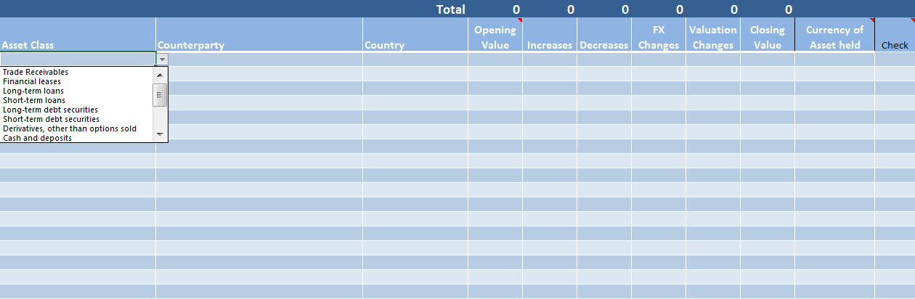

Opening value should equal the closing value of the previous quarter

#### 2.4.2.1 Asset Classes

#### Other Assets

**Tangible fixed assets:** The market value of fixed assets such as the business premises, computer and other office equipment and furniture. Aircraft or other assets leased on operating leases (where the Company is the lessor), and vehicles owned by the company should also be included.

**Debtors:** Any trade debtors.

**Financial leases:** The opening and closing value of financial leases should be entered here together with any transactions and valuation changes. The capital element only should be reported in the position and transactions data. Accrued interest should be reported separately in column L.

**Short-term loans:** Loans made by the Company including collateralized loans. Short-term relates to loans and overdrafts having an original maturity of one year or less.

**Long-term loans:** Loans made by the Company including collateralized loans. Long-term relates to loans having an original maturity of more than one year - regardless of the remaining time to maturity.

**Other:** Any other assets including tax.

#### Securities & Investments

**Bonds & Notes:** Bonds and notes are to be recorded so that details of the capital and interest are shown separately. The capital element is to be recorded at market price excluding accrued interest. The entry under “Interest earned” (column L) should be interest earned on an accruals basis in the period. Outstanding interest and the movement in interest are to be entered in the asset class Income earned but not paid.

**Money Market Instruments:** Money market instruments should be treated in the same way as conventional bonds or zero-coupon bonds as appropriate.

**Derivatives:** Data on Forward Contracts, Futures & Options, OTC Options, and Swaps is collected in this section. Over-the-counter and exchange traded derivative contracts, with the exception of OTC options sold should be treated as assets. All derivative contracts are to be included in the opening and closing positions at **marked-to-market value**, not nominal value. Contracts with a negative marked-to-market value should be subtracted from contracts with a positive marked-to-market value.

In relation to exchange traded derivatives, if variation margin calls result in a payment or receipt of funds, they should be recorded as transactions. Payments should be entered as “increases in assets” with receipts as “decreases in assets”. Initial margins and other repayable deposits held as margin accounts should be included as assets in “Cash and deposits”. Any transaction in the underlying instrument or commodity should be excluded from derivatives but included under the appropriate financial instrument heading e.g. equities, bonds etc.

In relation to over-the-counter derivatives, for interest rate swaps and forward rate agreements (FRAs) net interest receipts should be reported as transactions in derivatives and recorded as “decreases in assets”. Net interest payments, which are effectively decreases in liabilities, should be recorded as “increases in assets”. For cross currency interest rate swaps net interest flows should be treated as transactions in derivatives.

At expiry of the contract, in addition to the net interest flow:

* settlement resulting in a net receipt of currency should also be recorded as a transaction in derivatives under “decreases in assets”. If the settlement results in a net payment of currency the amount involved should be recorded as a transaction in derivatives under “increases in assets”.
* a settlement results in an exchange of principals the difference between the principal translated at the exchange rate agreed in the swap contract and at the market rate at settlement should be recorded as a transaction in derivatives as described above.
* If for forward foreign exchange contracts at expiry the difference between the amounts converted at the contract rate and at the market rate prevailing should be recorded as a transaction in derivatives. If this settlement results in a gain this, gain should be recorded as “decreases in assets”.
* losses, which are effectively decreases in liabilities, should be recorded as “increases in assets”.

For options purchased, the related premium payments should be recorded as transactions in derivatives under “increases in assets”. If the option is exercised the net settlement flows should be recorded as transactions in derivatives as “decreases in assets”.

Similarly, if the option being exercised results in the delivery of the underlying instrument the difference between amounts converted at the strike price and at the market price of the underlying instrument (net settlement) should be recorded also as transactions in derivatives. However, the underlying instrument should be recorded as a transaction in that instrument at market price.

**Property & Land** held for investment purposes, investment fund holdings (**units in unit trust**), and **cash and deposits** should be recorded in this section.

#### Income earned not paid

Accrued income relating to income earned (accrued) but not paid by instrument. This should be recorded at instrument level with no country or counterpart required.

#### 2.4.2.2 Liability Classes

#### Other Liabilities

**Creditors:** Trade creditors

**Financial leases:** Opening and closing values and related transactions in finance leases where the company is the lessor should be entered here. The capital element of the lease should be included, with the interest payable entered in column L.

**Short-term loans:** Loans received by the company including collateralized loans from repurchase transactions, and permanent debt. Short-term loans and overdrafts are loans having an original maturity of one year or less.

**Long-term loans:** Loans received by the company including collateralized loans from repurchase transactions, and permanent debt. Long-term loans are loans having an original maturity of more than one year - regardless of the remaining time to maturity at the survey reference date.

**Other:** covers all other liabilities such as payables and accruals. If these items are substantial a note explaining the nature of the liability would be helpful.

#### Securities

**Bonds & Notes:** Bonds and notes issued by the company having an original maturity of one year or more, detailed by the country of the beneficial holder of the security.

**Money Market Instruments:** Money Market Instruments issued by the company, having an original maturity of one year or less, detailed by the country of the beneficial holder of the security.

**Derivatives:** (see Section 2.4.2.1 Derivatives)

#### Income due but not paid

Accrued income relating to income due (accrued) but not paid by instrument. This should be recorded at instrument level with no country or counterpart required.

#### 2.4.2.3Valuation of Bonds and Notes

Bonds and notes should be recorded, excluding accrued interest (clean price basis) using one of the market valuation methods listed below in order of preference and converted to Euros, at the mid-market exchange rate prevailing at the open and close of business in the period:

* a quoted traded market price
* the net present value of the expected stream of future payments/receipts associated with the securities
* for unlisted securities, the price used to value securities for accounting or regulatory purposes, etc.
* for deep discount or zero-coupon securities, the issue price should be used.

Accrued interest should be recorded separately in the asset class *Income earned but not paid*.

### 2.4.3 Shareholders’ Funds

In the *Shareholders’ Funds* worksheet, we look for the value of the Irish group.

Quoted companies should complete the Shareholders’ Funds worksheet by reference to their market capitalisation. While this provides the best method of valuing the equity liability, it does mean that the Balance Sheet Summary on the final worksheet of the form will not balance.

In most other cases the best approximation to “value” is consolidated shareholders’ funds (i.e. net assets). The opening and closing positions should include the share capital, retained earnings, other comprehensive income and all other items reflected in the Statement of Changes in Equity.

Changes in equity positions due to retained earnings should be filed under “Valuation changes”: thus, the figure recorded in Item 11 of the Profit and Loss worksheet should be incorporated within the “Valuation changes” column.

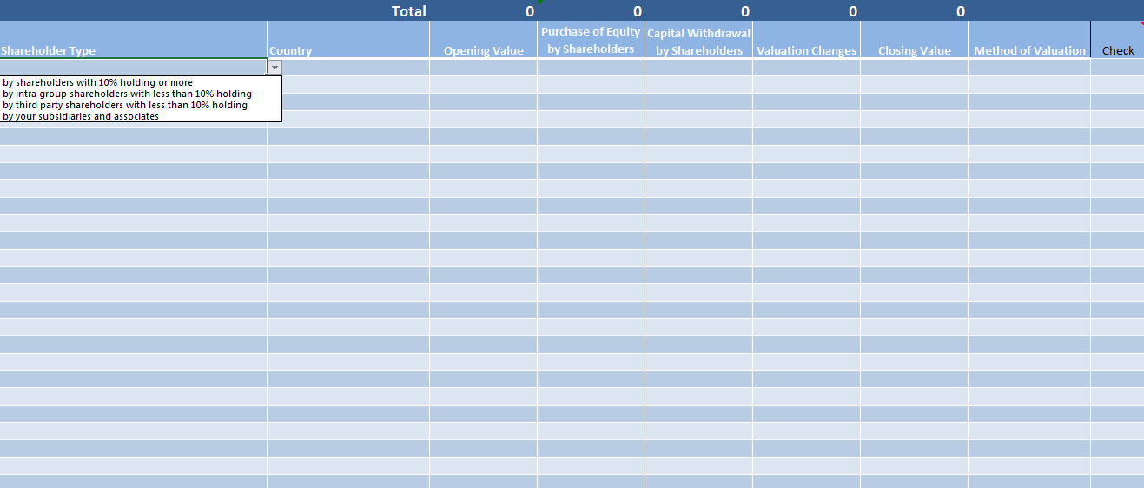

**Method of Valuation** is chosen from a drop-down menu:

List price

Net asset value

Recent transaction price

Other

**Shareholder Type** and the **Country** of the shareholder are chosen from drop-down lists

### 2.4.4 Balance Sheet Summary

The same broad principles of accounting methodology apply to the data reported in the BOP44 form, namely the following:

* Total Assets must equal Total Liabilities plus Total Equity, i.e. the balance sheet must balance.
* Asset transactions must equal Liability transactions plus changes in value of Shareholder Funds, i.e. cashflows must reconcile.

The *Balance Sheet Summary* worksheet acts as a check to ensure that the balance sheet credits (Shareholders’ Funds and Liabilities) equal the debits (Equity Investments and Assets). All cells in this worksheet, except the Comment box, are auto-calculated from data in the workbook and so are locked for editing. Any disparities will be highlighted in row 13 of the worksheet, and the comment box should be used to record the reason for these differences. Any disparities will be queried by a member of the BOP team.



The Comment box should record the reason/s for any difference between Assets and Liabilities above and/or any other points which are relevant to the return.

# Section 3: Appendix

## 3.1 Definitions

**Direct Investment:** For Balance of Payments purposes**, direct** investment involves an entity (the direct investor) acquiring an intendedlong-term interest in another enterprise (the direct investment enterprise). This long-term interest is defined as a holdingof at least 10% of the voting share capital. The direct investment relationship can extend to a number of companies in thewider group. **Fellow enterprises** are defined as those enterprises that are under the control or influence of the sameimmediate or indirect investor, but neither fellow controls or influences the other fellow enterprise.

Investors not classified as direct investors are **portfolio** investors. Examples are:

1. an individual with a less than 10% holding of the voting shares
2. companies in which you hold less than 10% of the voting shares

The diagram and paragraph below illustrate these investment relationships and the reporting categories on the form:

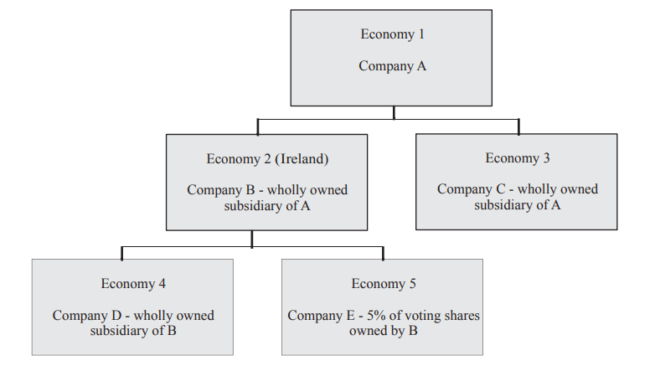

Economy 2 is Ireland and Company B is the Reporting Entity.

* Company A is the immediate parent (direct investor) of Company B. Company B reports its consolidated value to its shareholder, Company A, under the “shareholders with 10% holding or more” category.
* Company C is another group company under the control of the same immediate investor but Companies B and C do not control each other (Company C is a Fellow Company of Company B).
* If in this scenario Company C has an equity investment in Company B of less than 10% then this should be reported as “Investment by a fellow company holding less than 10% of the company's equity”.
* A Third Party Company is any other Investor with equity investment of less than 10% who is not covered in the Fellow definition outlined above.
* Company D is a direct subsidiary (direct investment enterprise) of Company B. Company B reports the consolidated value of its investment in Company D in Section 3 in the “investment of 10% or more in companies/branches” category.
* Company B is a portfolio investor in Company E. Company B reports the consolidated value of its investment in Company E under the “investments of less than 10% in Third party companies” category.
* If Company B had portfolio investment of less than 10% in Company C, this is viewed as an investment in a Fellow Company.

**Third parties:** All persons, individual or corporate, not classed as direct investors or direct investment enterprises are to be covered under this heading. Examples are:

1. unconnected shareholders who each control less than ten per cent of the shares
2. government or supra-national agencies
3. the affiliates of other Irish companies

**Profits:** Profits for Balance of Payments purposes broadly follow the same method of calculation as standard Profit & Loss statements for Profits after tax and minority interests. However, the following should be excluded:

* capital and exchange gains/losses, realised or unrealised
* the write-off of abnormal bad debts and related provisions
* revaluation gains/losses
* extraordinary items

**Equity:** Equity securities are ordinary shares which give the holder the right to a proportional share of the net assets of the company.

Include:

* ordinary shares
* stocks
* participating preference shares
* depositary receipts (e.g., American depositary receipts) denoting ownership of equity securities issued
* equity securities that have been sold under repurchase agreements
* equity securities that have been lent under a securities lending arrangement

Exclude:

* non-participating preference shares (include these instruments under Bonds and notes)
* rights, options, warrants, and other derivative instruments
* equity securities that have been bought under repurchase agreements
* equity securities that have been acquired under a securities lending arrangement

**Bonds and Notes:** Bonds and notes refer to bonds, debentures, notes, etc. that usually give the holder the unconditional right to a fixed money income or contractually determined variable money income and have an original term to maturity of over one year.

Include:

* bonds such as treasury, zero coupon, stripped
* linked (e.g. dual currency), floating rate, equity-related (e.g. convertible bonds), Eurobonds
* asset-backed securities such as mortgage-backed bonds, collateralized mortgage obligations (CMO)
* index-linked securities (e.g. property index certificates)
* non-participating preference shares
* floating rate notes (FRN) such as perpetual notes (PRN), variable rate notes (VRN), structured FRN, reverse FRN, collared FRN, step up recovery FRN (SURF), range/corridor/accrual notes
* Euro medium-term notes (EMTN)
* schuldscheine (German) notes
* bonds with optional maturity dates, the latest of which is more than one year after issue
* debentures
* negotiable certificates of deposits with contractual maturity of more than one year
* other long-term securities
* bearer depositary receipts denoting ownership of debt securities issued by non-residents
* debt securities that you have sold under repurchase agreements; and
* debt securities that you have lent under securities lending arrangements

Exclude:

* derivative instruments
* loans
* trade credit and accounts receivable
* money market instruments (e.g., treasury notes, banker's acceptances, certificates of deposit with contractual
* maturity of one year or less, note issuance facilities, revolving underwriting facilities, and promissory notes)
* debt securities that you have bought under repurchase agreements
* debt securities that you have acquired under a securities lending arrangement

**Money market instruments (with an original maturity of one year or less):** Securitised instruments for which there is an organised secondary market. Money market instruments are generally of shorter maturity than bonds.

Include:

* Bankers’ acceptances
* Commercial paper
* Floating rate notes
* Negotiable certificates of deposit with a contractual maturity of less than one year
* Treasury bills and other short term tradable Government debt securities
* Bonds with an original maturity of less than one year
* Any other of the debt securities having an original maturity one year or less.

**Asset-backed securities:** In reporting the market value of holdings of asset-backed securities, the respondents must be aware of the possibility of early partial redemption of principal. The market value of the principal amount outstanding at open and close of business in the period should be reported; if principal has been repaid, this market value will not be the same as the original face value revalued at end-period market prices.

**Repurchase and Securities lending arrangements:** A repurchase agreement (repo) is an arrangement involving the sale of securities at a specified price with a commitment to repurchase the same or similar securities at a fixed price on a specified future date. A reverse repo is the same transaction seen from the other side, that is, an agreement whereby a security is purchased at a specified price with a commitment to resell the same or similar securities at a fixed price on a specified future date. Securities (or stock) lending is an arrangement whereby the ownership of a security is transferred in return for collateral, usually another security, under the condition that the security or similar securities will revert to its original owner at a specified future date.

**Credit Institutions:** Credit institutions are regarded as providers of conventional banking services by the banking authorities in the country concerned.

Irish credit institutions include:

* Irish branches of Irish banks and building societies
* Irish branches of foreign banks
* Irish bank subsidiaries (bank and non-bank) of foreign companies (bank and non-bank)

Irish credit institutions exclude:

* foreign banks, i.e. banks located abroad
* foreign branches of Irish banks
* foreign banking subsidiaries of Irish companies

Official international agencies such as the European Investment Bank, the World Bank, etc. should not be treated as banks.

## 3.2 Treatment of Instruments

**Treatment of securities involved in repurchase and securities lending arrangements**

Securities acquired under repurchase or securities lending arrangements are to be excluded from this form and the related collateralised loan is to be included under Short-term loans.

Securities sold under repurchase or securities lending arrangements are to be included under Money Market Instruments.

Securities acquired under repurchase or securities lending arrangements and subsequently sold to a third party should be reported as a negative holding, against the original collateralised loan.

All valuations of securities under repurchase or securities lending arrangements should be at market value.

**Treatment of depositary receipts**

Depositary receipts, which denote ownership of equity or debt securities issued, for instance, American depositary receipts (ADR) or bearer depositary receipts (BDR), should be attributed to the country of residence of the issuer of the security underlying the depositary receipt.

Financial intermediaries should not report holdings of any securities against which depositary receipts have been issued and sold.

If a depositary receipt has been issued before the financial institution arranging the issue has acquired the underlying securities, then that financial institution should report a negative holding in the underlying security.

**Treatment of stripped securities**

Stripped securities (strips) are securities that have been transformed from a principal amount with periodic interest coupons into a series of zero-coupon securities, with the range of maturities matching the coupon payment dates and the redemption date of the principal amount.

For official strips, i.e. where an underlying issue has been designated as eligible for stripping and the issuer appoints strip dealers the strips remain the direct obligation of the original issuer, and the residence of the issuer of the strips remains the same as for the original security.

Entities who request that a settlement or clearing house create strips from an existing security issued should not report ownership of the underlying security once the strips have been created.

For unofficial strips issued without the authorisation of the original issuer (e.g. where strips have been created and issued by a dealer with a trust or other vehicle holding the original security to back the new stripped securities in the form of a certificate issued by the trust), then the residency of the issuer of the strips is that of the entity that has issued the strips. In turn, such an issuer of strips should report its ownership of the original underlying securities which continue to exist.

Strips with an original maturity of less than one year are classified as money market instruments.

## 3.3 ISO Country Codes

|  |  |
| --- | --- |
| **Country Code** | **Country Name** |
| IE | Ireland |
| GB_UK | UK - Excluding NI |
| GB_NI | Northern Ireland |
| US | United States |
| NL | Netherlands |
| DE | Germany |
| FR | France |
| CH | Switzerland |
| BE | Belgium |
| AU | Australia |
| AT | Austria |
| CN | China |
| DK | Denmark |
| IT | Italy |
| JP | Japan |
| LU | Luxembourg |
| PL | Poland |
| SG | Singapore |
| ES | Spain |
| SE | Sweden |
| ZA | South Africa |
| Z9 | Rest of World |
| AD | Andorra |
| AE | United Arab Emirates |
| AF | Afghanistan |
| AG | Antigua and Barbuda |
| AI | Anguilla |
| AL | Albania |
| AM | Armenia |
| AO | Angola |
| AQ | Antarctica |
| AR | Argentina |
| AS | American Samoa |
| AT | Austria |
| AW | Aruba |
| AX | Aland Islands (Finland) |
| AZ | Azerbaijan |
| BA | Bosnia and Herzegovina |
| BB | Barbados |
| BD | Bangladesh |
| BE | Belgium |
| BF | Burkina Faso |
| BG | Bulgaria |
| BH | Bahrain |
| BJ | Benin |
| BL | Saint Barthelemy |
| BM | Bermuda |
| BN | Brunei Darussalam |
| BO | Bolivia |
| BQ | Bonaire, St Eustatius, and Saba |
| BR | Brazil |
| BS | Bahamas |
| BT | Bhutan |
| BV | Bouvet Island |
| BW | Botswana |
| BY | Belarus |
| BZ | Belize |
| CA | Canada |
| CC | Cocos (Keeling) Islands |
| CD | Congo, the Democratic Republic of the |
| CF | Central African Republic |
| CG | Congo |
| CH | Switzerland |
| CI | Cote d'Ivoire |
| CK | Cook Islands |
| CL | Chile |
| CM | Cameroon |
| CN | China |
| CO | Colombia |
| CR | Costa Rica |
| CV | Cape Verde |
| CW | Curacao |
| CX | Christmas Island |
| CY | Cyprus |
| CZ | Czech Republic |
| DE | Germany |
| DJ | Djibouti |
| DK | Denmark |
| DM | Dominica |
| DO | Dominican Republic |
| DZ | Algeria |
| EC | Ecuador |
| EE | Estonia |
| EG | Egypt |
| EH | Western Sahara |
| ER | Eritrea |
| ES | Spain |
| ET | Ethiopia |
| FI | Finland |
| FJ | Fiji |
| FK | Falkland Islands (Malvinas) |
| FM | Micronesia, Federated States of |
| FO | Faroe Islands |
| FR | France |
| GA | Gabon |
| GB | United Kingdom |
| GD | Grenada |
| GE | Georgia |
| GF | French Guiana |
| GG | Guernsey |
| GH | Ghana |
| GI | Gibraltar |
| GL | Greenland |
| GM | Gambia |
| GN | Guinea |
| GP | Guadeloupe |
| GQ | Equatorial Guinea |
| GR | Greece |
| GS | South Georgia and the South Sandwich Islands |
| GT | Guatemala |
| GU | Guam |
| GW | Guinea-Bissau |
| GY | Guyana |
| HK | Hong Kong |
| HM | Heard Island and McDonald Islands |
| HN | Honduras |
| HR | Croatia |
| HT | Haiti |
| HU | Hungary |
| ID | Indonesia |
| IE | Ireland |
| IL | Israel |
| IM | Isle of Man |
| IN | India |
| IO | British Indian Ocean Territory |
| IQ | Iraq |
| IR | Iran, Islamic Republic of |
| IS | Iceland |
| IT | Italy |
| JE | Jersey |
| JM | Jamaica |
| JO | Jordan |
| JP | Japan |
| KE | Kenya |
| KG | Kyrgyzstan |
| KH | Cambodia (Kampuchea) |
| KI | Kiribati |
| KM | Comoros |
| KN | St Kitts and Nevis |
| KP | Korea, Democratic People's Republic of (North Korea) |
| KR | Korea, Republic of (South Korea) |
| KW | Kuwait |
| KY | Cayman Islands |
| KZ | Kazakhstan |
| LA | Lao People's Democratic Republic |
| LB | Lebanon |
| LC | Saint Lucia |
| LI | Liechtenstein |
| LK | Sri Lanka |
| LR | Liberia |
| LS | Lesotho |
| LT | Lithuania |
| LU | Luxembourg |
| LV | Latvia |
| LY | Libya |
| MA | Morocco |
| MC | Monaco |
| MD | Moldova, Republic of |
| ME | Montenegro |
| MG | Madagascar |
| MH | Marshall Islands |
| MK | Macedonia, the Former Yugoslav Republic of |
| ML | Mali |
| MM | Myanmar |
| MN | Mongolia |
| MO | Macau |
| MP | Northern Mariana Islands |
| MQ | Martinique |
| MR | Mauritania |
| MS | Montserrat |
| MT | Malta |
| MU | Mauritius |
| MV | Maldives |
| MW | Malawi |
| MX | Mexico |
| MY | Malaysia |
| MZ | Mozambique |
| N1 | Communaute Economique et Monetaire de L'Afrique Centrale (CEMAC) |
| N2 | Eastern Caribbean Currency Union (ECCU) |
| NA | Namibia |
| NC | New Caledonia |
| NE | Niger |
| NF | Norfolk Island |
| NG | Nigeria |
| NI | Nicaragua |
| NL | Netherlands |
| NO | Norway |
| NP | Nepal |
| NR | Nauru |
| NU | Niue |
| NZ | New Zealand |
| OM | Oman |
| PA | Panama |
| PE | Peru |
| PF | French Polynesia |
| PG | Papua New Guinea |
| PH | Philippines |
| PK | Pakistan |
| PL | Poland |
| PM | Saint Pierre and Miquelon |
| PN | Pitcairn |
| PR | Puerto Rico |
| PS | Palestine, State of |
| PT | Portugal |
| PW | Palau |
| PY | Paraguay |
| QA | Qatar |
| RE | Reunion |
| RO | Romania |
| RS | Serbia |
| RU | Russian Federation |
| RW | Rwanda |
| SA | Saudi Arabia |
| SB | Solomon Islands |
| SC | Seychelles |
| SD | Sudan |
| SE | Sweden |
| SG | Singapore |
| SH | St Helena |
| SI | Slovenia |
| SJ | Svalbard and Jan Mayen |
| SK | Slovakia |
| SL | Sierra Leone |
| SM | San Marino |
| SN | Senegal |
| SO | Somalia |
| SR | Suriname |
| SS | South Sudan |
| ST | Sao Tome and Principe |
| SV | El Salvador |
| SX | St Maarten |
| SY | Syrian Arab Republic |
| SZ | Swaziland |
| TC | Turks and Caicos Islands |
| TD | Chad |
| TF | French Southern Territories |
| TG | Togo |
| TH | Thailand |
| TJ | Tajikistan |
| TK | Tokelau |
| TL | Timor-Leste |
| TM | Turkmenistan |
| TN | Tunisia |
| TO | Tonga |
| TR | Turkey |
| TT | Trinidad and Tobago |
| TV | Tuvalu |
| TW | Taiwan, Province of China |
| TZ | Tanzania, United Republic of |
| U2 | Euro area (Member States and Institutions |
| U4 | Extra Euro area (changing composition) |
| UA | Ukraine |
| UG | Uganda |
| UM | United States Minor Outlying Islands |
| US | United States |
| UY | Uruguay |
| UZ | Uzbekistan |
| VA | Holy See (Vatican City State) |
| VC | St Vincent and the Grenadines |
| VE | Venezuela |
| VG | Virgin Islands, British |
| VI | Virgin Islands, U.S. |
| VN | Viet Nam |
| VU | Vanuatu |
| WF | Wallis and Futuna |
| WS | Samoa |
| YE | Yemen |
| YT | Mayotte |
| Z9 | World not allocated geographically |
| ZA | South Africa |
| ZM | Zambia |
| ZW | Zimbabwe |
| 1A | International organisations |
| 1B | United Nations Organisations |
| 1C | IMF (International Monetary Fund) |
| 1D | WTO (World Trade Organisation) |
| 1E | IBRD (International Bank for Reconstruction and Development) |
| 1F | IDA (International Development Association) |
| 1G | ICSID (International Centre for Settlement of Investment Disputes) |
| 1H | UNESCO (United Nations Educational, Scientific and Cultural Organisation) |
| 1J | FAO (Food and Agriculture Organisation) |
| 1K | WHO (World Health Organisation) |
| 1L | IFAD (International Fund for Agricultural Development) |
| 1M | IFC (International Finance Corporation) |
| 1N | MIGA (Multilateral Investment Guarantee Agency) |
| 1O | UNICEF (United Nations Children's Fund) |
| 1P | UNHCR (United Nations High Commissioner for Refugees) |
| 1Q | UNRWA (United Nations Relief and Works Agency for Palestine) |
| 1R | IAEA (International Atomic Energy Agency) |
| 1S | ILO (International Labour Organisation) |
| 1T | ITU (International Telecommunication Union) |
| 1U | Rest of UN Organisations n.i.e. |
| 1U1 | UNECE (United Nations Economic Commission for Europe) |
| 4A | European Union Institutions, Organs, and Organisms (excluding ECB) |
| 4B | EMS (European Monetary System) |
| 4C | EIB (European Investment Bank) |
| 4D | EC (European Commission) |
| 4E | EDF (European Development Fund) |
| 4F | European Central Bank |
| 4G | EIF (European Investment Fund) |
| 4H | ECSC (European Community of Steel and Coal) |
| 4I | Neighbourhood Investment Facility |
| 4J1 | European Parliament |
| 4J2 | Council of the European Union |
| 4J3 | Court of Justice |
| 4J4 | Court of Auditors |
| 4J5 | European Council |
| 4J6 | Economic and Social Committee |
| 4J7 | Committee of Regions |
| 4J8 | Other small European Union Institutions (Ombudsman, Data Protection Supervisor, etc.) |
| 4R | EU-Africa Infrastructure Trust Fund |
| 4S | ESM (European Stability Mechanism) |
| 4T1 | EBA (European Banking Authority) |
| 4T2 | ESMA (European Securities and Markets Authority) |
| 4T3 | EIOPA (European Insurance and Occupational Pensions Authority) |
| 4U | EURATOM |
| 5B | BIS (Bank for International Settlements) |
| 5C | IADB (Inter-American Development Bank) |
| 5D | AfDB (African Development Bank) |
| 5E | AsDB (Asian Development Bank) |
| 5F | EBRD (European Bank for Reconstruction and Development) |
| 5G | IIC (Inter-American Investment Corporation) |
| 5H | NIB (Nordic Investment Bank) |
| 5I | Eastern Caribbean Central bank (ECCB) |
| 5J | IBEC (International Bank for Economic Co-operation) |
| 5K | IIB (International Investment Bank) |
| 5L | CDB (Caribbean Development Bank) |
| 5M | AMF (Arab Monetary Fund) |
| 5N | BADEA (Banque arabe pour le developpement economique en Afrique) |
| 5P | CASDB (Central African States' Development Bank) |
| 5Q | African Development Fund |
| 5R | Asian Development Fund |
| 5S | Fonds special unifie de developpement |
| 5T | CABEI (Central American Bank for Economic Integration) |
| 5U | ADC (Andean Development Corporation) |
| 5W | Banque des Etats de l'Afrique centrale (BEAC) |
| 5Z | Other International Financial Organisations n.i.e. |
| 6B | NATO (North Atlantic Treaty Organisation) |
| 6C | Council of Europe |
| 6D | ICRC (International Committee of the Red Cross) |
| 6E | ESA (European Space Agency) |
| 6F | EPO (European Patent Office) |
| 6G | EUROCONTROL (European Organisation for the Safety of Air Navigation) |
| 6H | EUTELSAT (European Telecommunications Satellite Organisation) |
| 6I | EMBL (European Molecular Biology Laboratory) |
| 6J | INTELSAT (International Telecommunications Satellite Organisation) |
| 6K | EBU/UER (European Broadcasting Union/Union europeenne de radio-television) |
| 6L | EUMETSAT (European Organisation for the Exploitation of Meteorological Satellites) |
| 6M | ESO (European Southern Observatory) |
| 6N | ECMWF (European Centre for Medium-Range Weather Forecasts) |
| 6O | OECD (Organisation for Economic Co-operation and Development) |
| 6P | CERN (European Organisation for Nuclear Research) |
| 6Q | IOM (International Organisation for Migration) |
| 6Z | Other International Organisations (non-financial institutions) |
| 7A | WAEMU (West African Economic and Monetary Union) |
| 7B | IDB (Islamic Development Bank) |
| 7C | EDB (Eurasian Development Bank) |
| 7D | Paris Club Creditor Institutions |
| 7E | CEB (Council of Europe Development Bank) |
| 7F | International Union of Credit and Investment Insurers |