## Form for a Public Service Body to submit a request to the Central Statistics Office for microdata[1] to be anonymised[2] under Article 7 of the EU Data Governance Act

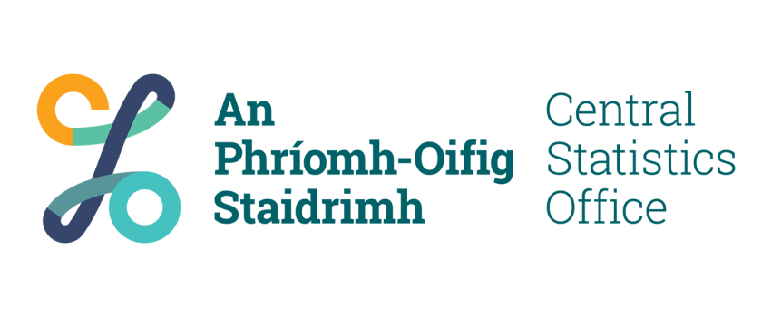

**CSO Anonymisation Service Application Form for Public Service Bodies**

**Application form for a Public Service Body to submit a request to the Central Statistics Office for microdata to be anonymised under Article 7 of the EU Data Governance Act.**

**This form is to be used by a Public Service Body (PSB), as the data controller, when submitting a request to the Central Statistics Office (CSO), the data processor, for the service of anonymising a specified microdata file:**

**The service will involve the following steps:**

* **The CSO to accept a confidential microdata file from the PSB;**
* **The CSO to produce an Anonymised Microdata File (AMF) from the confidential microdata file;**
* **The CSO to provide the AMF to the PSB;**
* **The CSO to delete the copy of the original confidential microdata file provided by the PSB.**

PSBs that decide to share data within the context of Article 7 of the EU Data Governance Act are the data controllers for any data, including any protected data, being provided to the CSO.

The CSO[3], in providing the assistance referred to in Article 7 of the EU Data Governance Act, acts as a data processor under instructions of the data controller.

The request to the CSO must be made by the designated data owner of the dataset within the PSB.

Data Governance Act:

<https://eur-lex.europa.eu/legal-content/EN/TXT/PDF/?uri=CELEX:32022R0868>

**Section A – Public Sector Body information**

|  |  |
| --- | --- |
| PSB Name: |  |
| PSB address: |  |
| Data owner name: |  |
| Data owner position: |  |
| Data owner email: |  |
| Data owner phone number: |  |

**Section B – Dataset (microdata) information**

|  |  |
| --- | --- |
| Dataset name: |  |
| Reference period: |  |
| Dataset format: |  |
| Is there a codebook available for the dataset? | Yes/No (delete as appropriate)  If yes, please attach it to the application. |

**Section C – Purpose of service request**

Please outline the reason for requesting this service from the CSO, details on the structure of the AMF being sought e.g., list of variables to be made available, preferred data output format, identification of key analysis variables, number of records and confirmation of whether personal or sensitive commercial data involved. Also include the eventual benefits that could be achieved through use of this service:

**Section D - Declaration**

**Declaration to be completed by PSB data owner:**

I confirm that the details provided in this request to the CSO for anonymisation of a PSB dataset are correct.

Name:

Position:

Organisation:

***Please note that any reference to signature and date in this document can be read as meaning the typed name and date where such an application is forwarded electronically.***

1. Microdata are sets of records containing information on individuals, households, or businesses.
2. Anonymisation is the process of turning data with direct identifiers e.g., personal data, into anonymous information so that an individual record in a dataset is not (or is no longer) identifiable.
3. The CSO is designated as the competent body within the meaning of Article 7 of the EU Data Governance Act through [Statutory Instrument 272/2024](https://www.irishstatutebook.ie/eli/2024/si/272/made/en/print).